FOR IMMEDIATE RELEASE
August 17, 2021
- Yvonne Cai is a Chinese Nationalist who programmed many of the Dominion Voting Systems in the State of Wisconsin. All the firmware computer programming for Wisconsin’s elections, for those counties using Dominion Voting Machines, was written by Serbian programmers.
- The Wisconsin Election Commission knew all of this for more than a year yet did nothing. In fact they have been covering it up from Wisconsin citizens for at least three years.
- Yvonne Cai was the key person for Dominion to program the Project Files for the November 3, 2020 election. Project files are the software updates necessary for each new election. They contain such things as the names of the candidates running for office, party affiliations, school referendums, the ballot design itself - everything you see on a paper ballot when you cast your vote.
- Miss Cai worked as an employee of Dominion out of their Toronto, Canada office. Thus the vast majority of the election software programming came from outside the United States. When Wisconsin voters fed their paper ballots into the Dominion Voting tabulators their votes cast were read and processed by Chinese Nationalist Yvonne Cai’s work.
- It was not only for the November 3, 2020 election as Miss Cai performed other work for Dominion as far back as 2012. Miss Cai is an educated and trained Software Engineer. She obtained a Master’s Degree in Software Engineering at Western University in 2017, and her Bachelor’ of Engineering, at the University of Electronic Science and Technology of China.
- She began working at Dominion Voting Systems in Toronto at least as early as 2012. She performed firmware programming work for Dominion in 2012 and also in more recent years. Firmware programming is the computer software for the internal hardware components of the voting system machines.
- Miss Cai left Dominion Voting a few months after the November 3, 2020 election. Her whereabouts are unknown at this time. Hundreds of emails were reviewed for this press release sent to Yvonne Cai by numerous Wisconsin election Clerks.
- Cai used yyvonne.cai@dominionvotiong.com, on a regular basis, while at Dominion. This is all very troublesome as the President of Dominion Voting Systems, John Poulos (George Kopoulos is his given last name) admitted in a video that their voting systems are connected to the internet. Poulos is from Greece.
- This video was posted on YouTube, but they blocked it. The address of the video is https://www.youtube.com/watch?v=u9zLI2P3TG8.
- These Wisconsin election clerks knew, or should have known, they were dealing with a Chinese Nationalist and obtained their election programming from outside the United States.
- We ask how they received delivery of the programming, for each new election coming from Toronto, Canada to Wisconsin and did each Clerk view the software code delivered?
- It may surprise many people but Wisconsin State law, per statute, prevents any person including the election Clerks from viewing the software and firmware which counts our votes. The Wisconsin Election Commission knew all this information also, yet never disclosed it to Wisconsin citizens/voters. Some of Cai’s work is shown on page 3 of this manual:
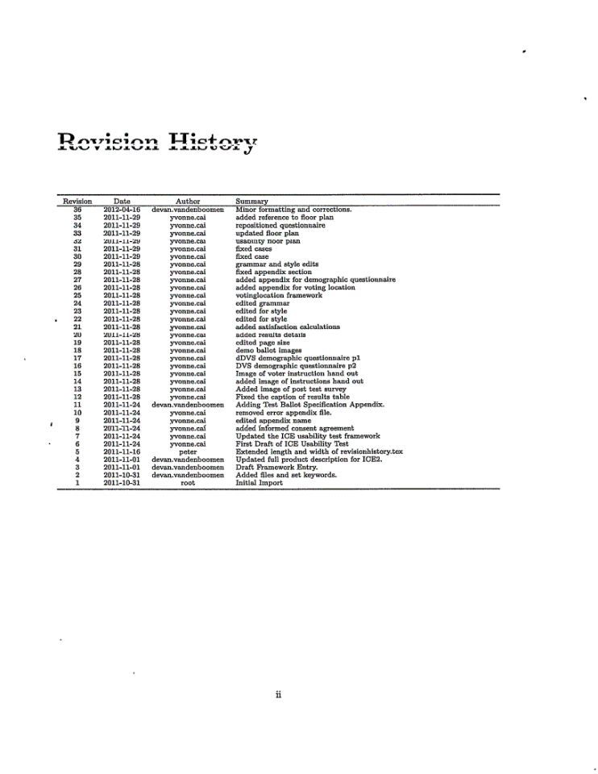
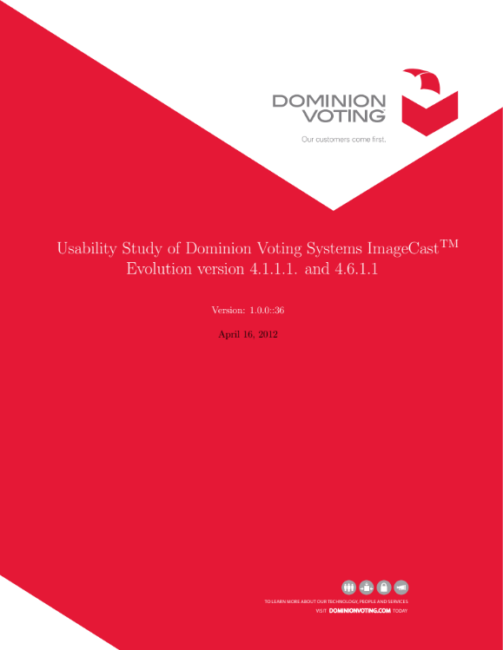
- The vast majority of the firmware computer programming for the Dominion Voting machines used in Wisconsin elections was performed by Serbians in Belgrade, Serbia. Goran Obradovic and Bojan Djordjevic (also Dordevic) are listed as inventors on many of Dominion’s patents.
- Their names can be viewed by conducting a patent search on the US Patent and Trademark website. Mr. Obradovic in particular holds the Title at Dominion of the Director of Development.
- A few of the patent numbers with Mr. Obradovic’s name on them include: 9870667, 9870666, 9710988, 8195505 and there are many more. Neither Mr. Obradovic or Dordevic are American Citizens. Wisconsin voting systems manufactured and serviced by Dominion have a much deeper tie to Belgrade Serbia. As stated, the firmware is programmed by Serbians. Their office is located at Osmana Dikica 18, 11060 Beograd-Palilula Serbia. The name of that division or sister company is Predstavnistvo Dominion Voting Systems Corporation Beograd, from a review of their corporation filing papers from the Government of Serbia.
- The software, firmware and support staff at this Dominion location includes upwards to fifty people: Mirjana Elez the Human Resources Manager, Ruzica Matic Product Owner, Slavko Duricin Microsoft SQL expert, Neda Vukman Software Developer, Nenad Nikolic, Bojan Janjic Software Engineer, Ivan Bulut Senior Software Engineer, Srdjan Saric Software Developer, Bojan D. Software Engineer, Branko Kolasinovic Senior Software Engineer, and many more software programmers are stationed there. Some of these people are no longer employed by Dominion.
3 of 4
- When Wisconsin voters feed paper ballots into a Dominion machine the votes are not counted nor tabulated by our election Clerks. The Clerks have never even viewed the software or firmware code which really counts and totals our votes. Our votes are being counted by the hidden computer code written by a Chinese nationalist and Serbian programmers.
4 of 4

