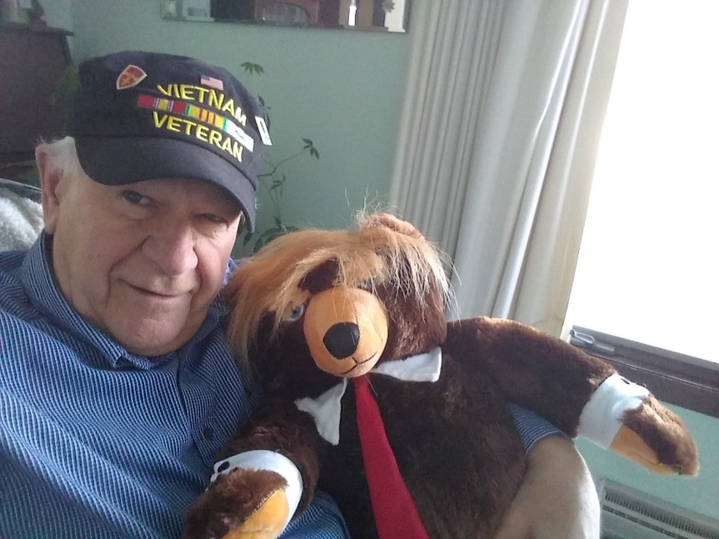
We have your back!
"We're on the brink of WWIII"
Patriots! Thanks to Biden’s open borders, we now have terrorists embedded in democrat’ sanctuary cities coast to coast. Even the main street media is now predicting a homegrown terrorist attack in on the horizon. Please pass our "Executive Protection" protocols out to all candidates on both sides of the aisle.
We recommend using check lists and event specific case studies in your Risk Management workshops. Your goal is to make sure all candidates and their support staff march to the same drummer. Following is an example of how we work with Senator Ron Johnson’s staff when they come into Door County:
The Door County Republican Party recently held a meet and greet with Senator Ron Johnson, at the Door County Fire Bar and Grill in Sturgeon Bay. Ask expected we were asked to reserve a parking place near the venue. Unfortunately that predictability can make a candidate a sitting target.
To reduce the obvious risks all candidates face, we recommend placing orange cones at more than one, mutually exclusive, parking stall close to alternative entrances to the venue. For example, for a planned “meet and greet” at the Door County Fire bar and grill, we did the following.
- We placed three cones in the public parking lot close to the buildings rear entrance.
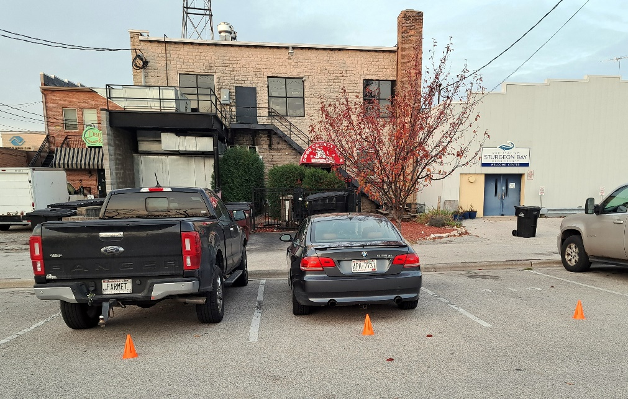
- We also placed three cones in the parking lot behind the ERA Starr Reality building, which allowed candidates the option of going through the ERA building coming out on 3rd avenue turning left down the sidewalk and entering Door County Fire through the front door next to an elevator and staircase to the second level.
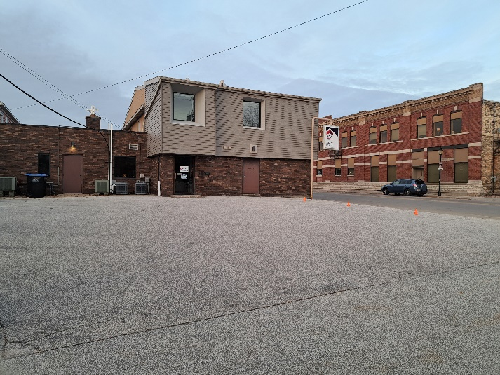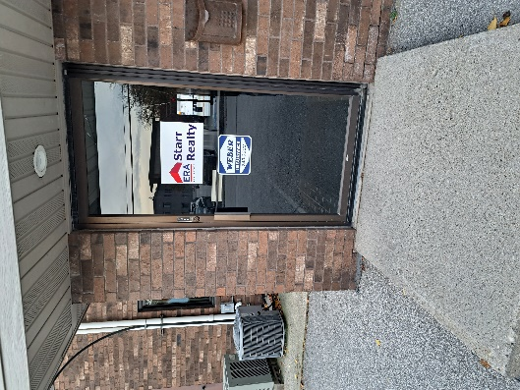
- We also recommended candidates, if there was a vacant stall not near the cones, to park there. This allows candidates to bob and weave, float like a butterfly and sting link a bee.
- When the event is over, it’s wise to leave out another exit. For example, if in the above case study, Senator Johnson chose to enter the front of the building, he’d leave through the back. If he entered through the back, his driver would come around and pick him up at the front of the building. The goal is to be as unpredictable as possible.
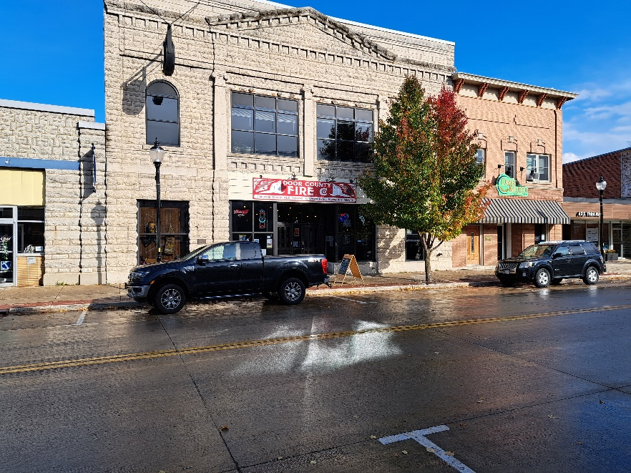
- We also recommended candidates, if there was a vacant stall not near the cones, to park there. This allows candidates to bob and weave, float like a butterfly and sting link a bee.
- When the event is over, it’s wise to leave out another exit. For example, if in the above case study, Senator Johnson chose to enter the front of the building, he’d leave through the back. If he entered through the back, his driver would come around and pick him up at the front of the building. The goal is to be as unpredictable as possible.
- It’s important for all Patriots to be trained in “Situational Awareness”! It’s the skill you develop, so you’re constantly aware of anyone or anything around you (suspicious person or package) that seems out of place and could pose a threat or danger to yourself and others. Note the “Situation Awareness Squad (SAS) we deployed when Senator Johnson came across the county line.
- Always include your County Republican Party QR code on all your handouts and publications.
- It’s going to be particularly important to include the “County” Republican Party QR code on all ballot applications and voting ballots, printed and distributed by registered printers in your District. This will go a long way to curb the voter fraud used to steel the 2020 presidential election!
- Click here to learn how to create your own county GOP QR Code.
- For example, click on this QR  and join our Door County Republican Party! Now review our Freedom Hill Patriots business plan and let’s take back our country in 2024.

We strongly recommend all patriots subscribe to the JBS’ New American magazine and read the August 14, 2023 interview with Senator Ron Johnson titled “Unscripted”! You can order extra copies at: www.shopJBS.org or call 1-800-342-6491.
God Bless and keep in touch at www.freedomhillpatriots.com
Back to School!
Our Freedom Hill Patriots are all encouraged to join the USCCA, take the concealed carry classes and get their permit. It’s critically important, for your own personal liability, self-defense and homeland security standpoint to know when, where, how and why we need trained patriots on the ground 24/7 365 days a year.
Join us at www.virleegunworksshootingcenter.com one Saturday a month to qualify for a Wisconsin Concealed Carry permit and show us how good you can shoot.

It time we hold the main-street media accountable for covering-up the corruption in the Biden’ family, the role they played in opening our borders and setting up sanctuary cities and bringing us to the brink of WWIII.
All Freedom Hill Patriots are encouraged to subscribe to the following publications.

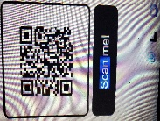
Visit our library at www.freedomhillpatriots.com

Please make sure all who travel with any candidate and/or elected official has a copy of our "Executive Protection" protocols. You can upload it off our www.freedomhillpatriots.com website.
***Schedule a review to make sure everyone is on the same page during the next sudden, unexpected, life-threatening event.

God Bless the USA

